Low Pass and Bandpass Filter Design Implemented with Microstrip Line Technology

Matt Frank and Xiaoyun Yang, Georgia Institute of Technology, Atlanta, GA

*Abstract* — This paper discusses the design procedures for both low pass and bandpass filters using microstip line technology. ADS is used for schematic simulation, Momentum is a field solver used for a more accurate characterization, and the filters are both fabricated for measurement with a network analyzer. The results for all cases are presented and discussed.

*Index Terms*— *bandpass filter, coupled line filters, low pass filter, microstrip, transmission lines*

# INTRODUCTION

F

ilters are used in all RF systems to reject unwanted signals, while leaving the desired signals mostly unaffected. A low pass filter is utilized when high frequencies must be eliminated or attenuated, while a bandpass filter passes signals over a set frequency range, and attenuates those outside the range. In addition to these typical filter behaviors, the filter can have a different response type, which usually depends on the application. A maximally flat response has no ripple in the passband, however the roll-off in the stopband is not very sharp, so higher order filters are required to achieve more attenuation. On the other hand, an equal ripple response has a fixed ripple in the passband, with the benefit of sharper roll-off in the stopband.

The objective of this paper is to design, then fabricate, both a low pass and bandpass filter using microstrip line technology. For the low pass filter, the desired specifications include a 3dB cutoff frequency of 1.1GHz, a maximally flat response, and greater than 16dB of attenuation at 2.6GHz. Specifications for the bandpass filter include a center frequency of 3.6GHz, 10 percent bandwidth about this frequency, an equal ripple response, while maximizing attenuation in the stopband. Both designs will be for a 50Ω system characteristic impedance, so it is desired that both filters minimize the return loss.



Fig. 1. Duroid Cross-Section [1]

Design of the filters is achieved using HPADS and Momentum for simulation and layout, then the designs are fabricated on a duroid substrate. Duroid has a relative permittivity of 6.15, a loss tangent of 0.002, is 50 mil thick, and has 1 mil thick copper for the signal transmission lines, and ground backplane. A cross section of the substrate is shown in Figure 1. To determine the S-parameters of the fabricated boards, a network analyzer is used.

# Low Pass Filter

Low pass filters are implemented to reject frequencies beyond a certain value. In microstrip technology the filters can be realized with a repeating network of shunt stubs. The designer has a few degrees of freedom, including the filter order and response type. A higher order filter will provide sharper roll off in the stop band. Sharper attenuation can also be achieved by allowing for an equal ripple in the pass band, versus a maximally flat response that rolls off more gradually. The following section outlines the procedure for a low pass filter design, and analyzes the resulting simulations.

## Design Procedure

The first step in designing a low pass filter with cutoff frequency of 1.1GHz, a maximally flat response in the passband, and 16 dB of attenuation at 2.6GHz is to develop a prototype which consists of ideal capacitors and inductors. Through the insertion loss method tables developed for higher order filters (see Appendix Table I), a prototype design can be determined based on the specifications. The prototype is normalized to the cutoff frequency and characteristic impedance of the network, so values are derived based on the filter response type and the filter order required to achieve the specified attenuation. It is then determined that a third order filter response is required consisting of a series inductor of *g* equal to 1, shunt capacitor of *g* equal to 2, and then series inductor of *g* equal to 1 followed by a load resistance with *g* of 1. See Figure 2.

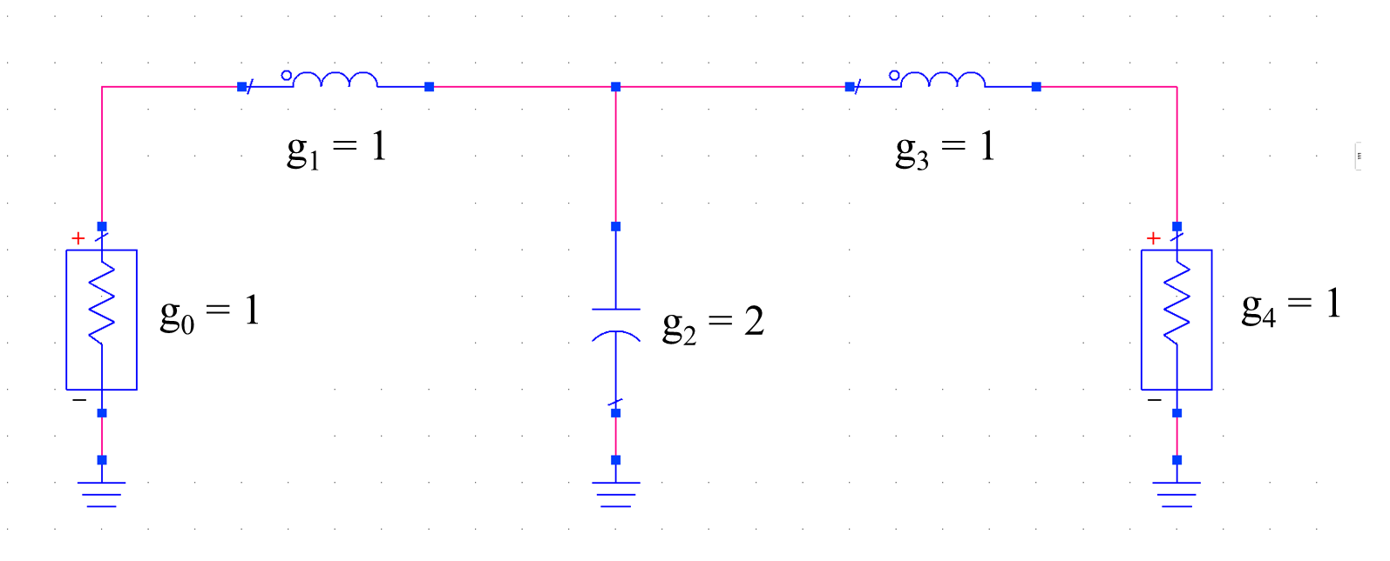

Fig. 2. Normalized Low Pass Filter Prototype Schematic

From this normalized prototype, actual values of inductance and capacitance can be determined with the following formulas

(1)

(2)

## A schematic for the prototype is shown in Figure 3. The prototype can then be simulated to ensure that the response is as expected, Figure 4, before the filter is implemented in microstrip technology.

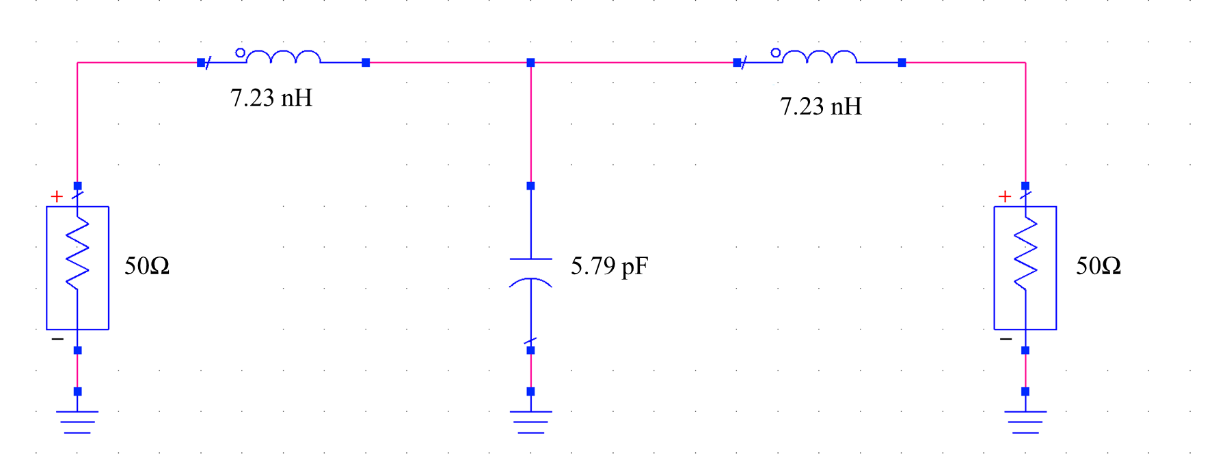

Fig. 3. Lumped Element Low Pass Filter Prototype

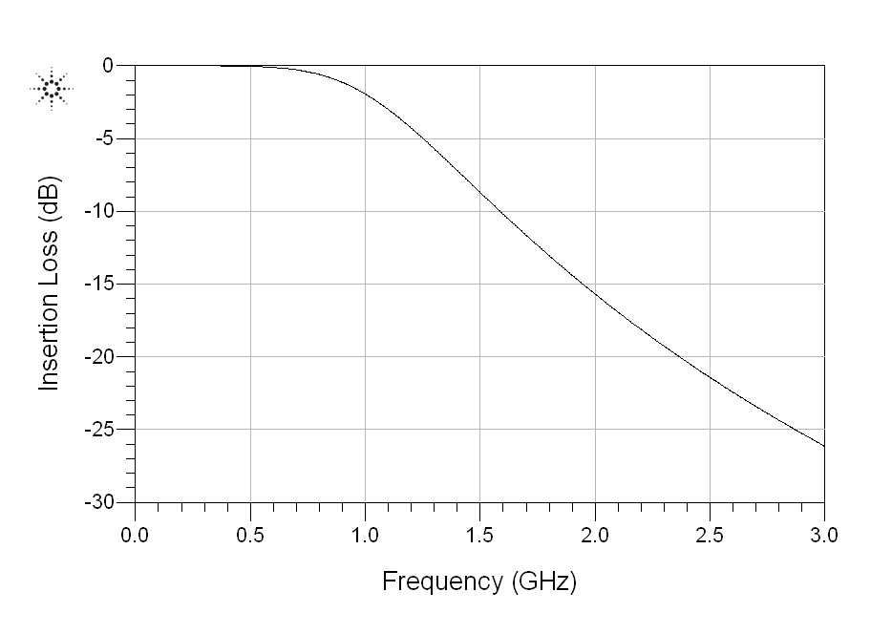

Fig. 4. Low Pass Filter Prototype Insertion Loss

## To generate the microstrip implementation from the prototype two transformations are required: Richard’s and Kuroda’s transformation. Richard’s transformation maps the frequency domain to the impedance domain, which allows conversion of inductors to short-circuited stubs of a set length, and conversion of capacitors to open-circuited stubs. The length in both cases works out to be λ/8, so that at frequencies twice the cutoff frequency the line appears to be λ/4 long, creating an attenuation pole. Then, by varying the characteristic impedance of the line, by changing the width, the desired inductance or capacitance can be achieved.

Fig. 5. Low Pass Filter Schematic

Since it would be physically impossible to implement the elements as is, all stubs are currently designed to lay right next to one another with no separation between stubs, Kuroda’s identities must be used. The identities can accomplish two necessary tasks, the first to create separation between the elements, and the second to convert the series inductors to shunt elements, so that Richard’s transformation can be applied. By adding unit, *λ/8* long characteristic impedance, stubs to the left of the first inductor, and the right of the second inductor, which are implemented as series short-circuit stubs, the transformed stubs will be open-circuit shunt stubs, with unit stubs to their right and left, respectively. The impedance of the stubs is also transformed, with the new value multiplied by *n2*, where

(3)

*Z2* is the characteristic impedance of the unit cell, and *Z1* is the normalized impedance, *g*, determined from the tables. Now there is a realizable implementation for microstrip technology. There are three open-circuited shunt stubs with proper separation, and normalized impedances. The last step is to multiply the normalized values by the 50Ω characteristic impedance and use a line calculation tool to determine the proper transmission line widths and lengths. The schematic for the first pass design is shown in Figure 5, with values for the components outlined in Table I. Lines of length *3λ/8* and with characteristic impedance of 50Ω are added to each end of the filter to allow for SMA connections for measurement.

## Circuit Simulation and Optimization

Once the initial design parameters are determined for the microstrip technology, a simulation is run to check that specifications are met. The tool used for simulation is Agilent Advanced Design System (ADS). Port terminations of 50Ω are added to each end of the filter, and these ports are used in an S-parameter simulation. The S-parameter is a frequency simulation that solves the S matrix across the swept range of frequencies. Insertion loss, S21, is the S-parameter that best characterizes the performance of the low pass filter. For the low pass filter, the frequencies of interest range from DC to 3GHz.

TABLE I

Low Pass Filter Design Parameters

|  |  |  |
| --- | --- | --- |
| Parameter | Schematic | Layout Optimized |
| *Z1* (Ω) | 200 | 200 |
| *W1* (mil) | 13.1 | 13.1 |
| *L1*(mil) | 680.2 | 719.5 |
| *Z2* (Ω) | 25 | 25 |
| *W2* (mil) | 211.3 | 211.3 |
| *L2*(mil) | 604.9 | 639.9 |

The results of the first pass schematic insertion loss simulation are shown in Figure 6 and Table II. For Figure 6 marker m1 is placed at the ideal cutoff frequency, 1.1GHz, and marker m2 is placed 1.5GHz from the cutoff. Initial results are very promising when compared to the specifications. The response is maximally flat, and at the 1.1GHz cutoff frequency, attenuation is 3.11dB, very close to the expected value, so no change is needed here. Also, attenuation at 2.6GHz is 15dB below the specified value. Therefore, no further tuning is needed at the schematic level and the layout can be generated.

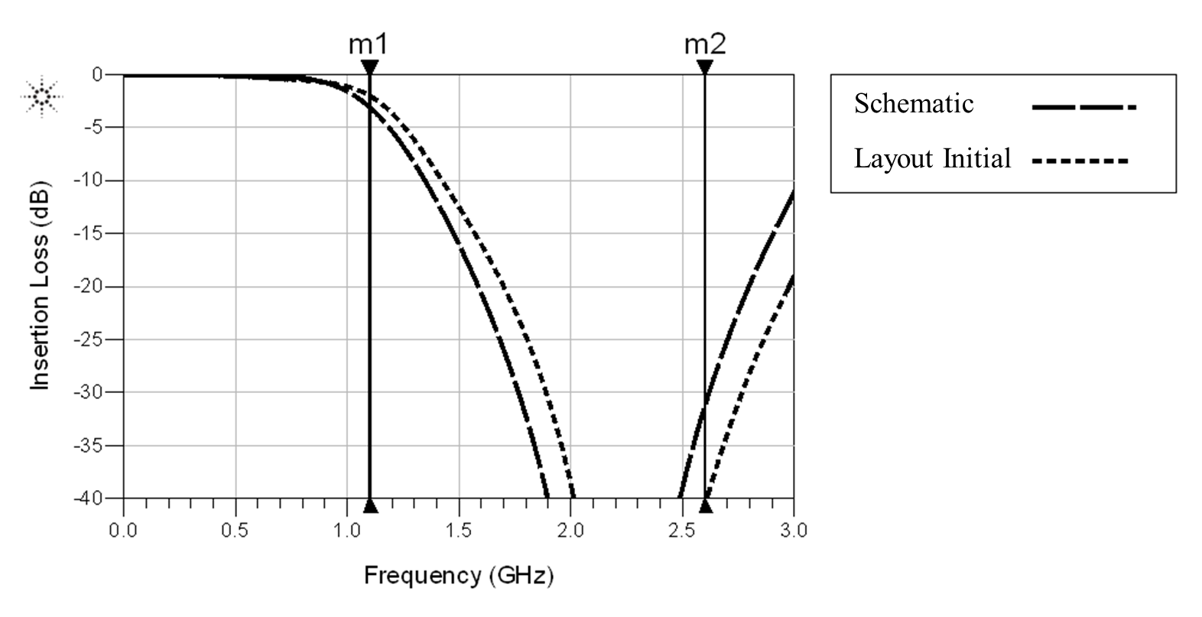

Fig. 6. Low Pass Filter Schematic and Initial Layout Insertion Loss

TABLE II

Low Pass Filter Simulation Results

|  |  |  |  |  |
| --- | --- | --- | --- | --- |
| Parameter | Schematic | Initial Layout | Final Layout | Measured |
| *IL at 1.1GHz* (dB) | 3.11 | 2.02 | 3.00 | 3.7 |
| *IL at 2.6GHz* (dB) | 31.2 | 40.5 | 30.7 | 43.9 |
| *fc*(GHz) | 1.095 | 1.167 | 1.10 | 1.065 |
| *RL at DC* (dB) | 108 | 60.2 | 59.7 | 60.2 |

## EM Simulation

A schematic simulation alone is not enough to capture the electric field behavior of the low pass filter that is set to be fabricated, therefore Momentum is used to more accurately characterize the network. Momentum is a field solver that more accurately calculates the S-parameters of the layout generated from the schematic simulation. The simulator takes in to account layout features, often undesirable ones, such as discontinuities between transmission lines of different widths, coupling between neighboring stubs, and parasitics caused by pads for solder, that change the behavior of the device under test.

The initial results for the Momentum simulation are shown along with the schematic results in Figure 6. Insertion loss at 2.6GHz is actually improved over the schematic simulation, with an increase from 31.2dB to 40.5dB. The reasoning for this is that the cutoff frequency is actually shifted by about 72MHz, and with the periodic nature of the filter, the point where the insertion loss begins to rise again is shifted as well. This specification is then not of much interest for the initial pass, because it is determined mainly by the filter order, and will most likely reduce as the cutoff frequency is tuned.

As for the cutoff frequency, the initial Momentum simulations show that it is roughly six percent greater than the desired value of 1.1GHz. In circuits, a low pass filter cutoff frequency is proportional to the capacitance. A higher capacitance in turn reduces the frequency. The second parallel shunt stub in this implementation has an impedance that looks capacitive, so if this value is increased by six percent, the cutoff frequency will theoretically reduce nearer to the desired value.

Another factor that must be taken in to account is that the maximally flat response is achieved by normalized impedance ratios of the inductive and capacitive elements. Therefore, the shunt stubs that represent inductors must be scaled by the same amount. The scaling is achieved by simply increasing the length of the stubs by the same percentage that the cutoff frequency is shifted by, since Richard’s transformation states that the imaginary impedance is proportional to the length of the stub. The characteristic impedance of the lines, then, remains unchanged.

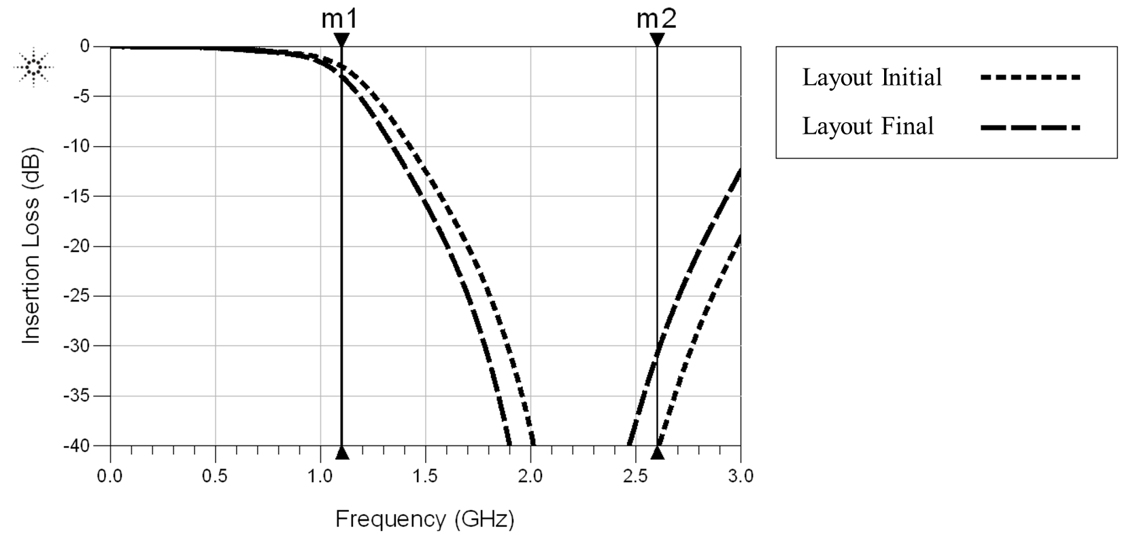

Fig. 7. Low Pass Filter Initial and Final Layout Insertion Loss

Tuning the layout using the method described above results in a solution that meets specifications in two iterations. Insertion loss for the final layout, alongside the initial layout, is shown in Figure 7. The response remains maximally flat and the corner frequency falls at 1.1GHz, while the insertion loss at 2.6GHz reduces to 30.7dB, close to the schematic result. As stated above, this reduction is expected due to the periodic nature of the filter, and the specification of 16dB insertion loss at this frequency is met. With all specifications met, the design is ready for fabrication.

## Layout and Fabrication

Layout is automatically generated from the ADS microstrip line schematic. The widths and lengths of the lines match what is seen in the schematic view, and the transmission lines are all properly connected. The fabrication process has limitations on line dimensions, however, so the layout must be double checked to ensure that no process rules are violated. The board that the filter is fabricated on is a maximum of six inches, so total length cannot exceed this value. With a substrate thickness of 50 mil, the width of a transmission line must then be less than 500 mil. The reason for this rule is that design equations for microstrip technology are for a width to thickness ratio less than 10, any other dimensions will have unexpected behavior. Also for this reason, the ratio of the width to the length of the line should be less than 0.4. Lastly, the minimum separation between lines is set at 10 mil. Any distances less than this can cause undesired coupling, or even short circuits that would bear the filter unusable. It is believed that the fabrication process follows a photolithography procedure [2]:

1) Photo mask is made based on the layout and Gerber files

2) Photoresist is spin-coated onto the duroid material (the original board)

3) Soft bake photoresist

4) A mask aligner is used to expose the resist coated board and photo mask is used to define the pattern

5) Post bake photoresist (optional depending on what kind of photoresist is used)

6) The photoresist is developed and the desired pattern is formed

7) An e-beam evaporator is used to deposit 1mil copper onto the developed board

8) The undesired copper is removed, as well as the photoresist

The final layout is shown in Figure 8. Transmission lines have been added on each end of the filter to allow for soldering of SMA connectors. The added lines were also included in schematic and momentum simulation, to verify performance is as expected. For the final design, the overall length is 5203 mil, and the width is 755.65 mil. All line dimensions are shown in mil and have values that follow the process rules outlined above.

## Measurements

Once the filter is fabricated and SMAs are soldered to each end, the S-parameters of the device can be measured using the Agilent Programmable network analyzer. Two port scattering parameters are measured from which the Insertion Loss and Return Loss can be directly calculated.

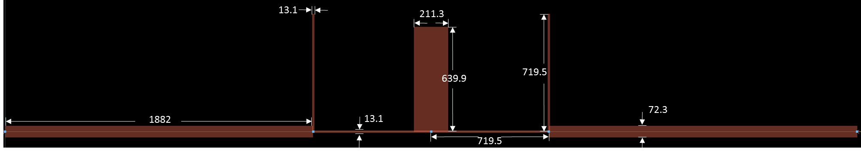 A network analyzer measures scattering parameters as ratios of complex voltage amplitudes. The primary reference plane lies within the analyzer itself, so the measurement includes losses and phase delays caused by the connectors, cables and transitions that are used to connect the device under test. These effects are generally represented by two error boxes on both sides of the device as shown in the block diagram of Figure 9.

Fig. 8. Low Pass Filter Layout



Fig. 9. Measurement Block Diagram [3]

In order to correct the error induced by the error box, calibration is implemented before the measurement. The procedure used for calibration is called *Thru, Reflect,* and *Line (TRL)*. The *Thru* connection is made by directly connecting port 1 to port 2 at the desired reference point. The *Reflect* connection uses a load having a large reflection coefficient, such as a nominal open or short. The *Line* connection involves connecting ports 1 and 3 together through a length of matched transmission line. The TRL procedure gives the values for five different parameters , which can be further used to calculate the ABCD matrix of the error box. After the ABCD matrix is determined, the measurement result can be error corrected and the actual scattering parameters of the device can be obtained. The programmable network analyzer used for this report implements the calibration procedure automatically as long as the TRL connections are applied in a given order.

The results of the measurements for the low pass filter are summarized in Table II and the following Figures, 10, 11, and 12, show the response compared to both the schematic and EM simulation. As expected, there are differences when measuring a real device, versus what is seen in simulation. This is because a simulation is an idealized environment, with results based on calculations and look up tables, while the fabricated device is subject to process variation. For example, although the filter dimensions are one value in schematic, the actual fabricated value can vary.

The most noticeable difference is that the cutoff frequency is about 35MHz less than the specified value of 1.1GHz, resulting in 3.7dB of attenuation at the cutoff frequency. This could be a result of slightly longer and wider shunt stubs than what was determined through simulation. In practice the slightly lower cutoff frequency may not be an issue, depending on the filter application. The other specifications differ slightly from what was simulated in ADS, however they meet the intended specifications. Insertion loss at 2.6GHz is almost 44dB, while the response remains maximally flat in the pass band. Return loss is also similar for all variations. The matching is excellent at low frequencies, and begins to increase as the cutoff frequency is reached. Also, the return loss for both ports is the same, indicating that the filter is symmetric.

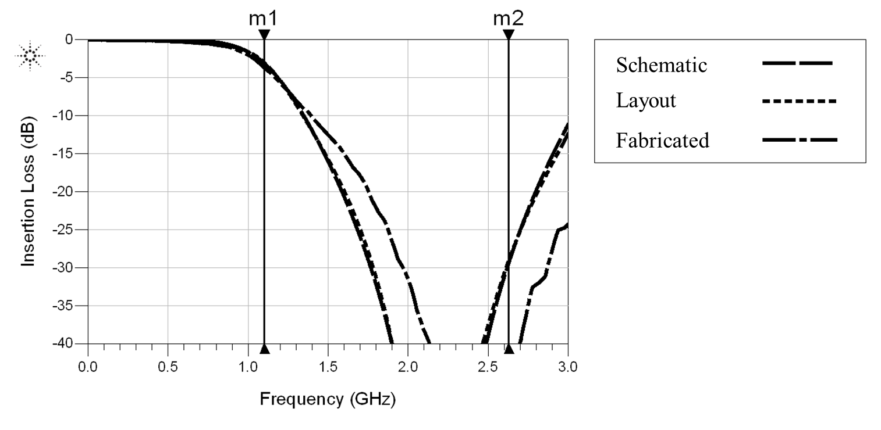

Fig. 10. Low Pass Filter Insertion Loss Comparison

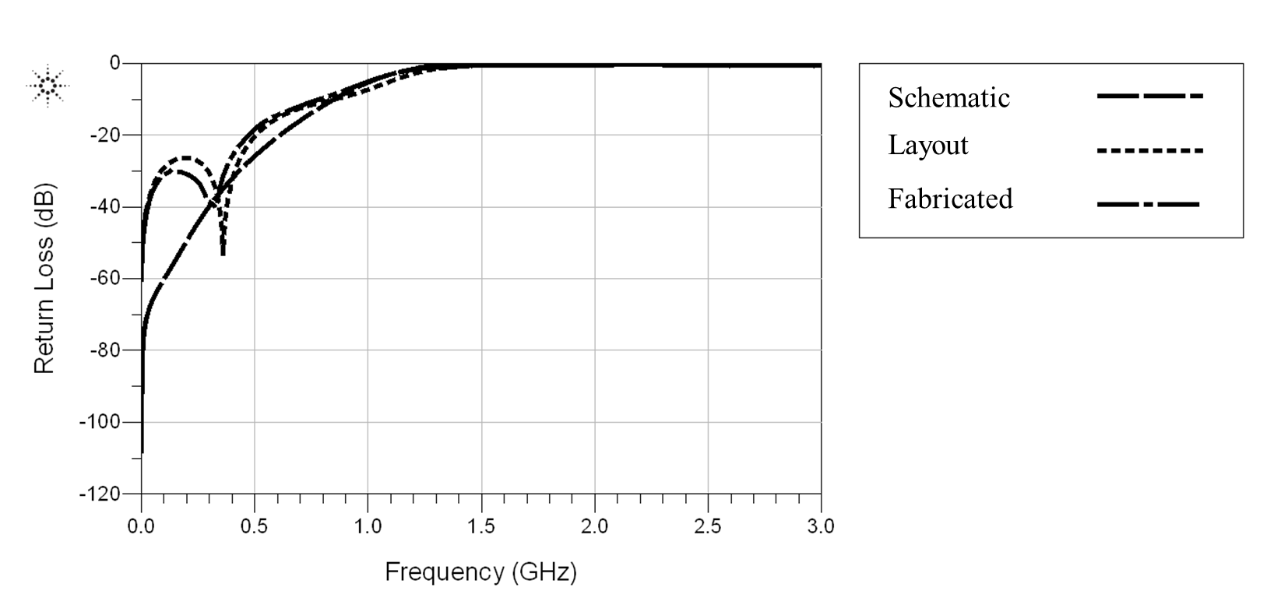

Fig. 11. Low Pass Filter Port 1 Return Loss Comparison

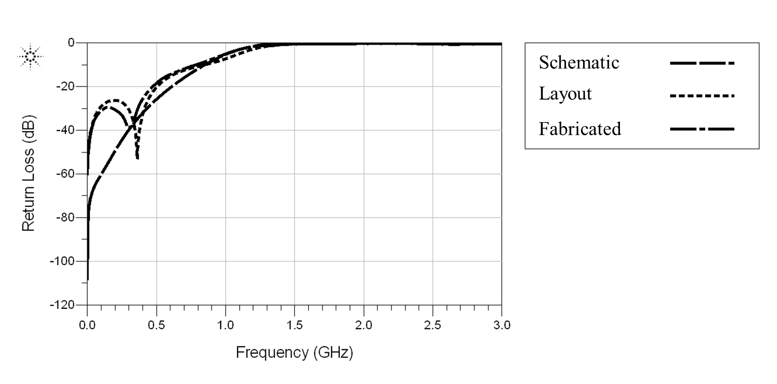

Fig. 12. Low Pass Filter Port 2 Return Loss Comparison

# Bandpass Filter

The bandpass filter is designed to pass signals over a set frequency range, the bandwidth, while attenuating those outside of this range. In microstrip technology, bandpass filters can be realized with cascaded coupled line sections. These coupled lines are uses to create a filter with a center frequency at 3.6GHz, a fractional bandwidth of 10% and 0.5 dB equal ripple within the passband. The design, simulation, and fabrication process are outlined, then differences between the actual device response and the desired response are discussed. After analyzing the simulation results, methods are discussed to tune the design at both the schematic and layout level, in an effort to meet the outlined specifications.

## Design Procedure

In order to achieve 16dB of attenuation 1.5GHz from the passband, as was done with the low pass filter, and to avoid using a transformer to match the load, causing unnecessary complication for the design and extra loss for the circuit, a four section coupled line filter was chosen. This requires an N = 3 normalized low pass filter prototype (see Appendix B). Similar to the low pass filter design, element values are found through tables (0.5dB and N=3) for equal-ripple low-pass filter prototype where the normalized inductance or capacitance values are listed as series inductance , then shunt capacitance and then series inductance The network is terminated by the load conductance . This filter prototype is shown in Figure 13.

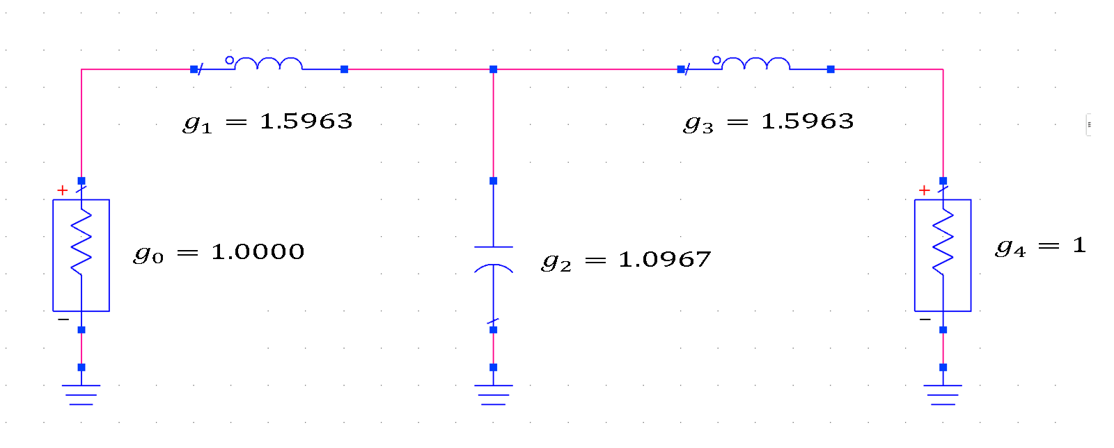

Fig. 13. Normalized Bandpass Filter Prototype

In order to convert the low-pass filter prototype into a band pass filter, the transformation equation as below for the frequency is used

(4)

where *ω0* is the center frequency and *Δ* is the fractional bandwidth. After the frequency substitution, the series inductor, , is transformed to a series LC circuit with element values

(5)

(6)

While the shunt capacitor, is transformed to a shunt LC circuit with element values

(7)

(8)

A lumped element circuit prototype for the bandpass filter is shown in Figure 14. Notice that the single L or C elements are replaced by series or parallel LC circuits. An S-parameter simulation demonstrates that the circuit is valid for the outlined specifications, Figure 15.

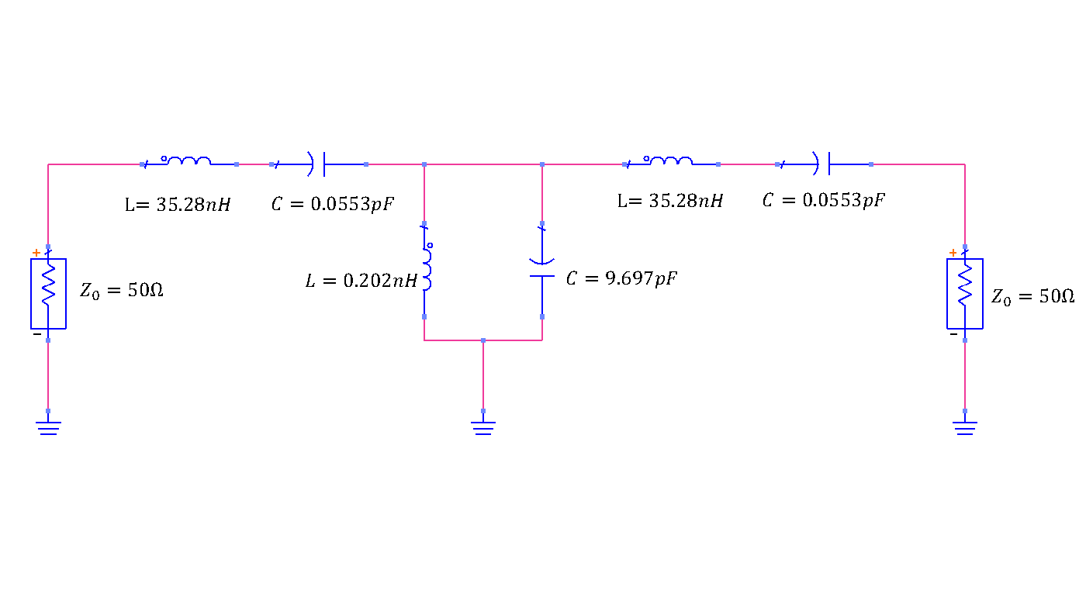

Fig. 14. Lumped Element Bandpass Filter Prototype

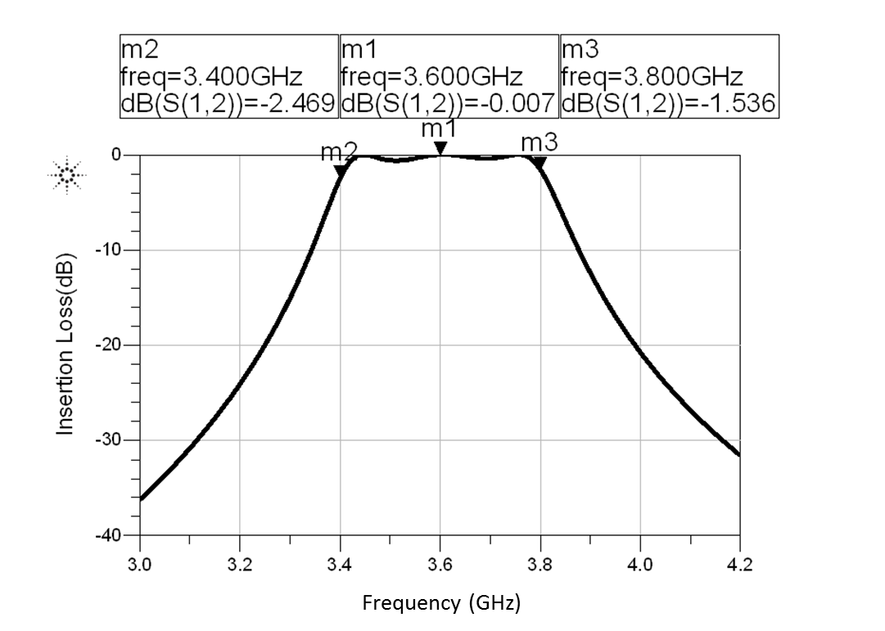

Fig. 15. Bandpass Filter Prototype Response

With the verification of the lumped element circuit design, equivalence analysis between the lumped elements and microstrip coupled line is applied. This involves two steps: 1) equivalence between the lumped circuit and an admittance inverter model; 2) equivalence between the admittance inverter model and the microstrip coupled line.

### Equivalence between the lumped circuit and an admittance inverter model;

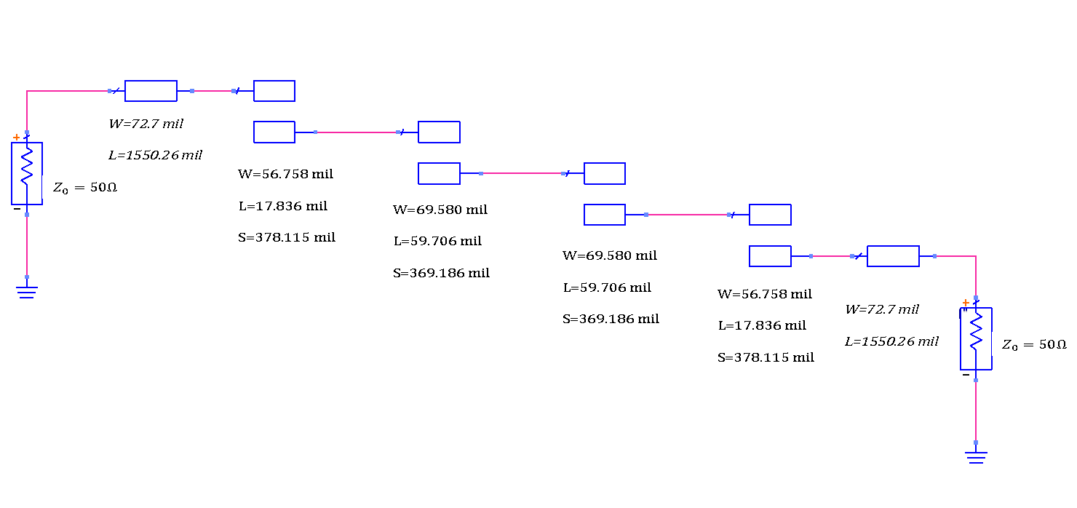 Based on the ABCD matrix analysis, an equivalence between the lumped elements circuit and the admittance inverter circuit can be established. For example, a transmission line of approximately long is equivalent to a circuit that consists of a shunt parallel LC resonator and admittance inverters have the effect of transforming a shunt LC resonator into a series LC resonator. These equivalences, accompanied by the element values given in the band pass filter lumped element circuit above give the required admittance value for the admittance inverter model circuit as follows

Fig. 16. Bandpass Filter Initial Design Schematic

(9)

(10)

(11)

(12)

### Equivalence between the admittance inverter model and the microstrip coupled line;

The second step for converting the lumped circuit into a microstrip circuit is to establish the equivalence between the admittance inverter model circuit and the coupled line, which allows the characteristic impedance for the coupled line to be found. When combined with the odd-even mode analysis of the coupled line section and ABCD matrix analysis, the even and odd mode characteristic impedances is given by

(13)

,

(14)

where *J*s are the admittance values calculated from lumped elements. Table III lists the calculated even odd mode characteristic impedances of the coupled line, where *n* stands for the section number, is the even mode impedance and is the odd mode impedance.

|  |  |  |  |  |
| --- | --- | --- | --- | --- |
| TABLE III  Even-Odd Mode Characteristic Impedance | | | | |
| *n* |  |  |  |  |
| 1 | 1.5963 | 0.3137 | 70.61 | 39.24 |
| 2 | 1.0967 | 0.1187 | 56.64 | 44.77 |
| 3 | 1.5963 | 0.1187 | 56.64 | 44.77 |
| 4 | 1.0000 | 0.3137 | 70.61 | 39.24 |

Once and are determined, LineCalc can be used to determine the dimensions of each coupled microstrip line section. The dimensions of the initial design are labeled in Figure 16 and outlined in Table IV. Added to the end of each line are long extension transmission lines for SMA solder connections.

TABLE IV

Bandpass Filter Coupled Line Dimensions

|  |  |  |  |  |  |  |  |
| --- | --- | --- | --- | --- | --- | --- | --- |
|  | Initial Design Parameters | | | Final Design Parameters | | | |
| *n* | *W (mil)* | *S (mil)* | *L (mil)* | | *W (mil)* | *S (mil)* | *L (mil)* |
| *1* | 56.76 | 17.84 | 378.12 | | 44.26 | 11.5 | 392.12 |
| *2* | 69.58 | 59.71 | 369.19 | | 46.58 | 47.71 | 380.69 |
| *3* | 69.58 | 59.71 | 369.19 | | 46.58 | 47.71 | 380.69 |
| *4* | 56.76 | 17.84 | 378.12 | | 44.26 | 11.5 | 392.12 |

## Circuit Simulation and Optimization

With microstrip dimensions for the bandpass filter determined, ADS can again be used to characterize the response. The circuit with dimension parameters given by the theory shows a frequency response as shown in Figure 17. As can be seen in the graph, the response shows a center frequency at 3.6GHz and a bandwidth of 11.4%. The defect comes from the slightly large ripple level within the bandwidth with a maximum ripple 1.42dB at 3.67GHz. In order to reduce the ripple level, *W, S, L* of the coupled line are set as tunable parameters while keeping the total circuit symmetric for the tuning process.

The ADS tuning functionality allows the designer to manipulate parameters, via sliders, and see instant changes in the simulation results. Using this method results in a few trends that are also useful when tuning the layout:

* Ripple in the pass band can be reduced by decreasing the width or separation between the N = 1,4 sections.
* Increasing the length of the transmission lines shifts the response to a lower frequency. This is related to the wavelength of the line.
* Decreasing the separation or width of N = 2,3 sections increases the roll off frequency of the higher frequency term.

While tuning these parameters careful consideration must be paid to the process dimension restrictions outlined in the low pass filter section.

A final optimization results in reduced ripple level in the passband, around 0.5dB, and a slightly increased bandwidth, up to 15.3% from 11.4%. There is a high likelihood that the momentum simulation greatly alters the response, so the added bandwidth is intended to allow for variations. The final schematic design parameters are given in Table IV and results are summarized in Table V.

|  |  |  |  |
| --- | --- | --- | --- |
| TABLE V  Bandpass Filter Simulation Results | | | |
|  | Schematic | Momentum | Measured |
| *f0* (GHz) | 3.573 | 3.615 | 3.910 |
| *Bandwidth* | 15.8% | 13.5% | 11.7% |
| *Ripple* (dB) | 0.234 | 0.519 | 1.628 |

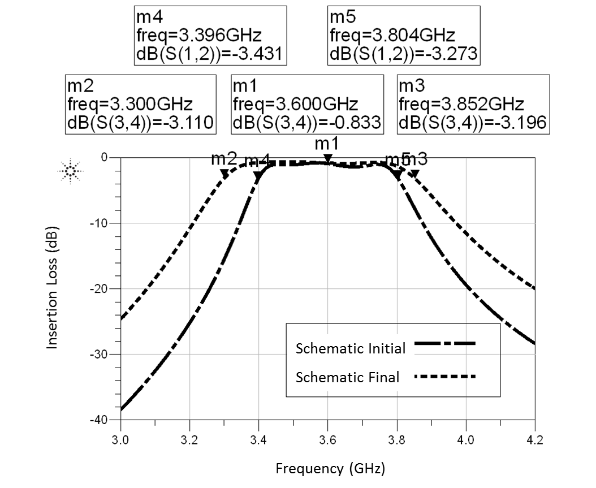

Fig. 17. Bandpass Filter Schematic Initial and Optimized Insertion Loss

## EM Simulation

In order to more accurately determine the frequency response of the final circuit, layout is generated from the schematic and momentum simulation is carried out where the substrate is defined as the duroid material from the introduction section and the port resistance defined as 50. The simulation is run over a frequency range from 3GHz to 4.2GHz. Momentum simulations for both the initial and final layouts are run while the schematic simulation and momentum simulation for the final design are also compared.

Figure 18 shows the initial layout and then the optimized version. It is clear from the first simulation that tuning is needed to meet the specifications. The bandwidth is much too low and the center frequency is too high. The same tuning methods as for the schematic are used to vary the microstrip dimensions. For instance, the line lengths are increased to shift the response to a lower frequency, while widths and separations are tuned in conjunction to reduce ripple and keep the response symmetric about the center frequency. Again, care is taken to make sure that dimensions follow all process rules. After multiple iterations a response is achieved that gives around around 0.5dB of ripple in the passband, a center frequency of 3.6GHz and fractional bandwidth of 13.5%.

Figure 19 compares the optimized schematic to the optimized layout. As can be seen, momentum simulation shows a narrower bandwidth 13.5% than schematic simulation 15.8%. This fractional bandwidth difference 2.3% could be due to the extra coupling at the joint of two coupled lines which is not taken into consideration with the schematic simulation. If, for example, the extra coupling leads to an increase of for 1.8%, then according to the equations given in the design section, a reduced bandwidth would be expected. However, the response meets specifications and is ready to be fabricated.

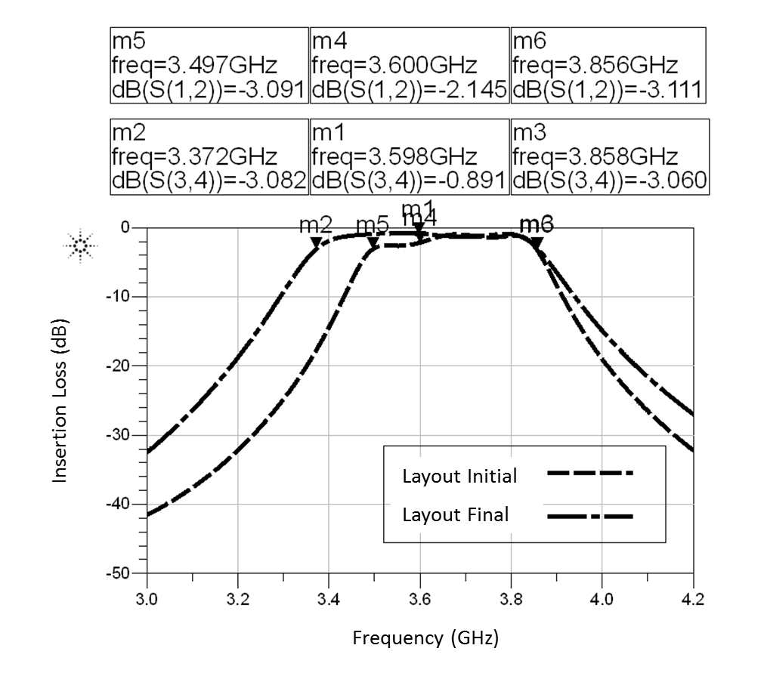

Fig. 18. Bandpass Filter Layout Initial and Optimized Insertion Loss

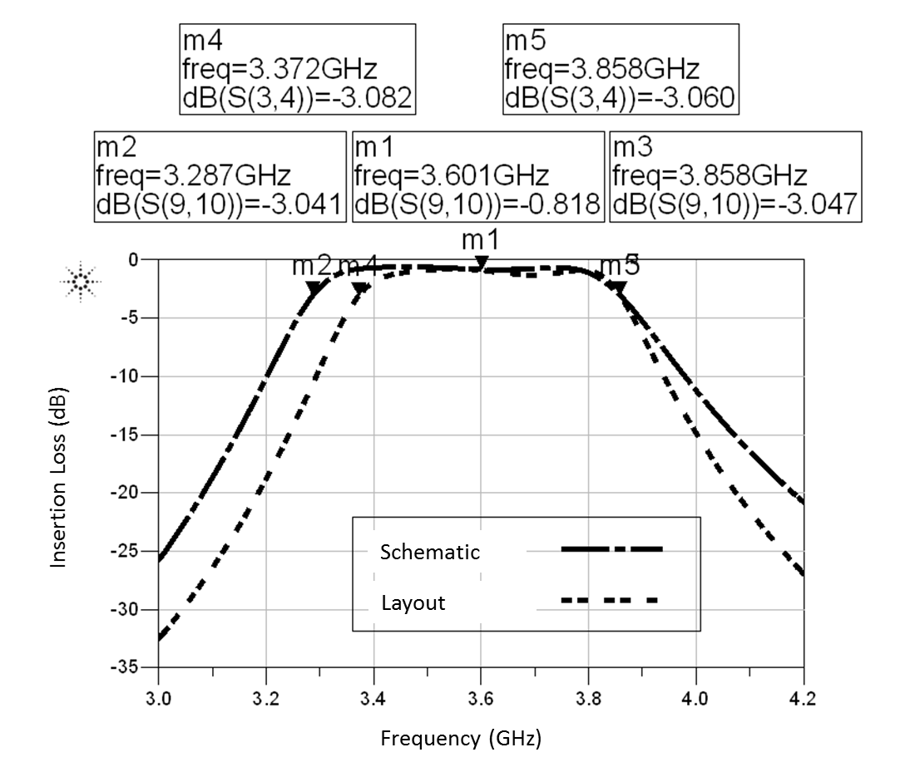

Fig. 19. Bandpass Filter Schematic and Layout Optimized Insertion Loss

## Layout and Fabrication

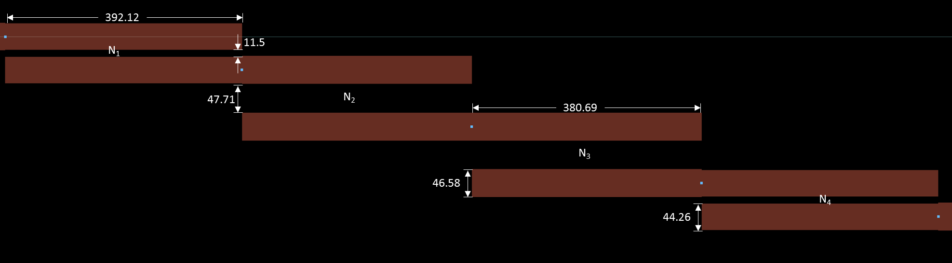The bandpass filter layout can be generated directly from the schematic after the parameters are optimized. The final design layout includes a four section coupled line with long extension transmission lines on both sides. Layout is shown with dimensions, in mil, in Figure 20. The extension lines are not shown so that greater detail can be seen in the coupled sections, but these lines are 46.26 mil wide and 775.13 mil long for 50Ω characteristic impedance. The overall length of the design is 3096 mil, while the width measures 351 mil.

Fig. 20. Bandpass Filter Layout

## Measurements

The same equipment, setup, and methods for the low pass filter are used to measure the response of the bandpass filter. Measurement of the bandpass filter takes place immediately after that of the low pass, so the calibration remains the same for either case. Insertion loss results for all three characterizations: schematic, momentum, and measured are shown in Figure 21, while the numerical results displayed in Table V.

As discussed earlier, the schematic and momentum results align closely with the desired specifications. However, there is quite a large discrepancy between the fabricated design and the simulation results. The most noticeable difference is that the entire response is shifted to a higher frequency. In practice, this is undesirable, especially if the application is expecting to receive signal at 3.4GHz. This behavior was seen, albeit to a lesser extent, when the final simulation parameters were first implemented in layout and a momentum simulation was run.

One possible cause for the shift is the extra parasitic coupling between the sections. During tuning, it was discovered that increasing the coupling by decreasing the separation causes the response to shift to higher frequencies. The parasitic coupling, along with any imperfection in fabrication, if only a fraction of a mil decrease in separation, could cause the differences between the final layout and measured response. In future design attempts it would make sense to use diagonal 50Ω characteristic impedance sections to reduce the parasitic coupling between lines.

Also, the ripple is much worse than the both the simulation and momentum responses, at 1.63dB, and does not meet specifications. The likely contributor to this ripple is due to the entire response shifting. The 0.5dB response is expected when the filter center frequency falls at 3.6GHz, however, when the frequency is shifted, there are undesirable results. This was also evident in the initial momentum simulation. Although the center frequency does not align with the specifications, the bandwidth, measured to be 11.7%, falls within a reasonable range of the specification.

Lastly, the return loss for both ports and for all three measurement methods are shown in the following figures. Figure 22 represents the return loss for Port 1, while Figure 23 is for Port 2. For both the schematic and momentum simulations, return loss in the passband is at least 10dB, indicating a relatively good match. Once again, the fabricated design does not perform as well. This is explained by the fact that the design is intended for 3.6GHz, and therefore this frequency would have the best matching. However, with the shift in frequency, the return loss suffers. Responses for S11 and S22 are similar, indicating that the filter acts symmetrically.

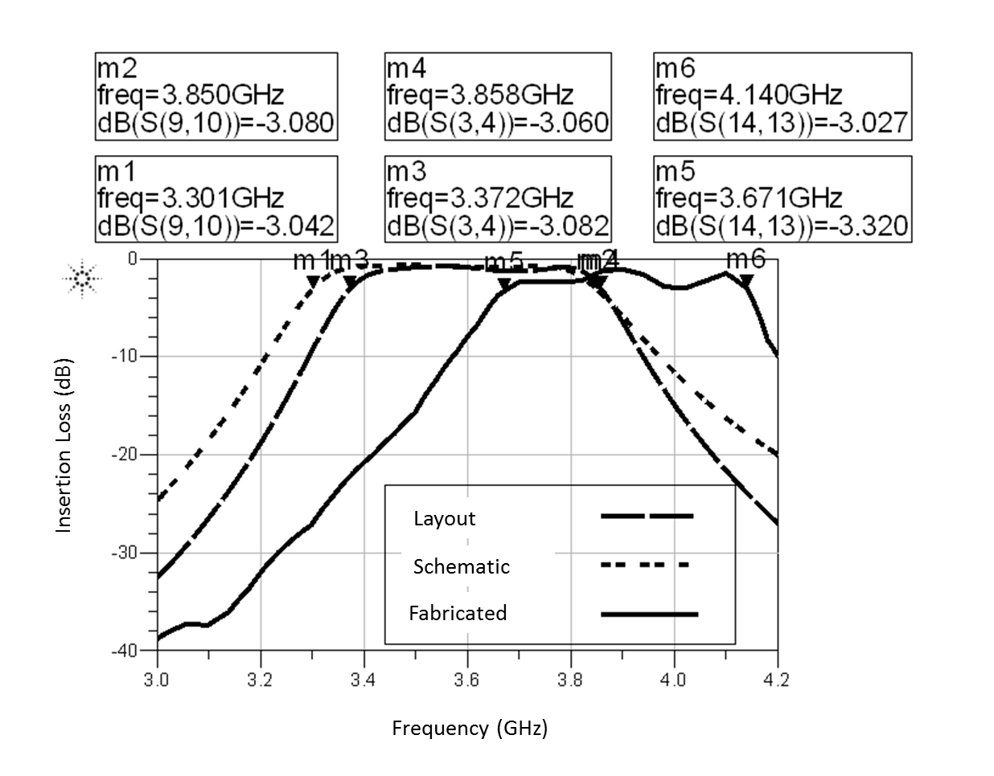

Fig. 21. Bandpass Filter Insertion Loss Comparison

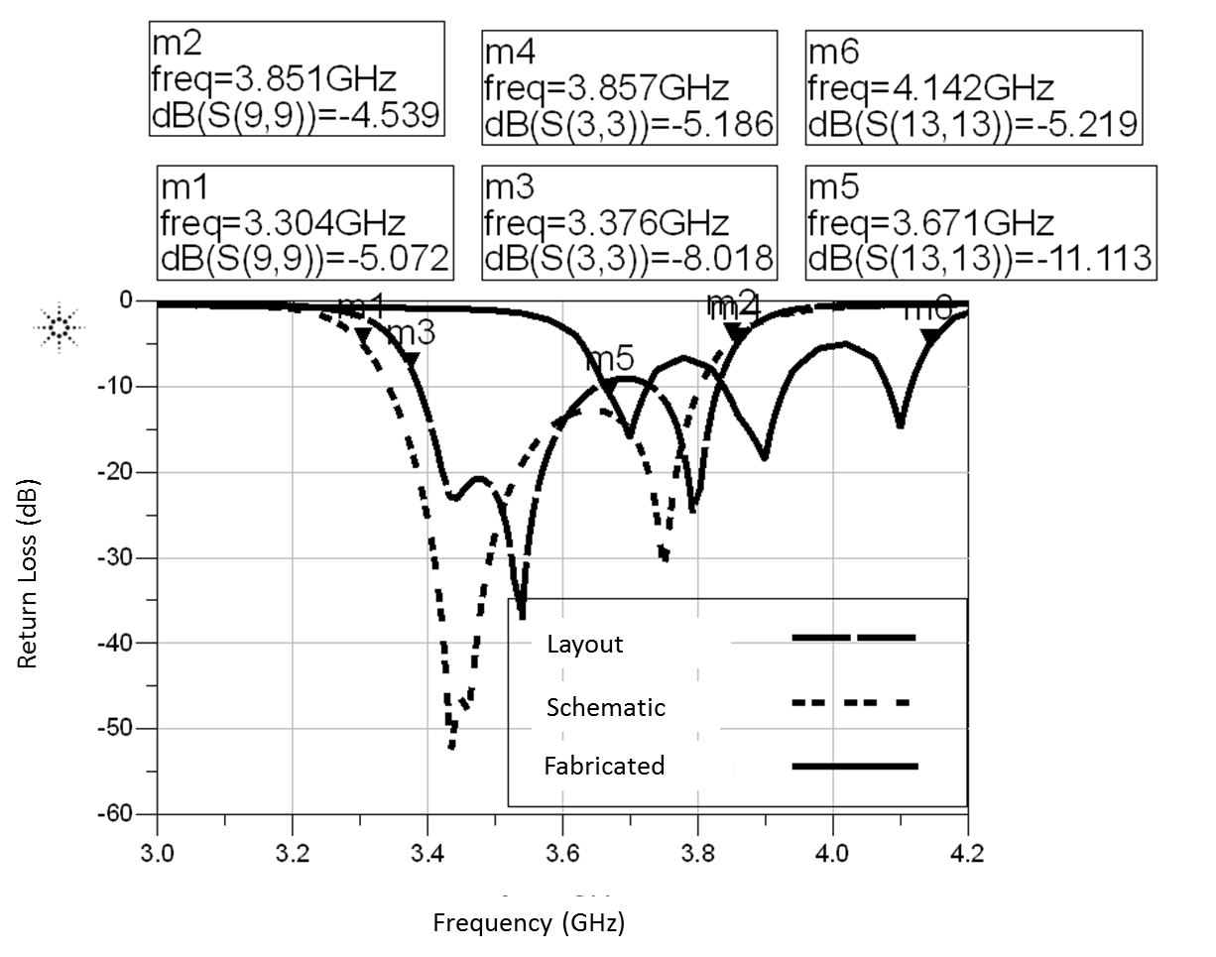

Fig. 22. Bandpass Filter Port 1 Return Loss Comparison

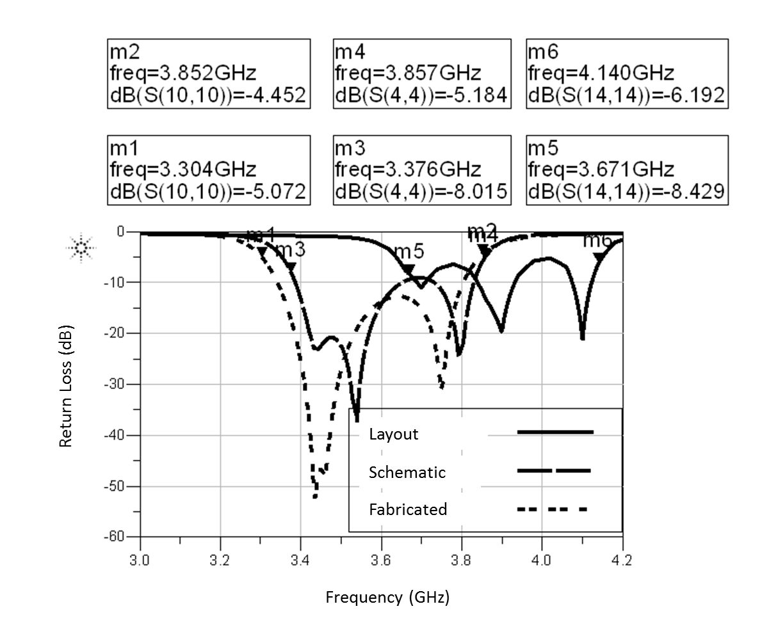

Fig. 23. Bandpass Filter Port 2 Return Loss Comparison

# Conclusion

The objective of this paper was to design both a low pass and bandpass filter using microstrip line technology. For each design, the process is outlined, starting from the analytical solutions, to schematic simulation, field solver simulation, fabrication, and finally measurement with a network analyzer. The goal for the low pass filter was to meet specifications which include a maximally flat response, cutoff frequency at 1.1GHz, and attenuation greater than 16dB at 2.6GHz, all while maximizing return loss and minimizing area. For the bandpass filter, specifications include a center frequency of 3.6GHz, 0.5dB equal ripple response in the passband, similar attenuation in the stopband as the low pass filter, and a 10% fractional bandwidth.

The low pass filter, which is third order, is implemented with open circuit stubs of varied characteristic impedance. Both the simulation and momentum results align with the specifications, however the cutoff frequency of the fabricated design is 35MHz lower than desired. This discrepancy is likely caused by slight variations in the dimensions of the fabricated design. For example, a slightly longer transmission line will result in a lower cutoff frequency. Practically for a low pass filter, 35MHz may not be an issue, however in future designs this discrepancy should be taken in to account.

For the bandpass filter, also third order, coupled line sections are used. Again, the schematic and momentum simulations have been successfully tuned so that the responses closely match the desired specifications. However, the fabricated filter falls short in this regard. There is a frequency shift of almost 300MHz, from 3.6GHz to 3.9GHz. In practical applications, this bandpass filter is almost unusable. The most likely cause for the shift is parasitic coupling between the filter sections, as well as the possibility of the fabricated dimensions being slightly different than those determined through simulation. In future design, better layout practices could be used to try to minimize parasitic effects.

Appendix

**Table I Element Values for Maximally Flat Low-Pass Filter Prototypes (*g*0 = 1*,ωc* = 1*, N* = 1 to 10)**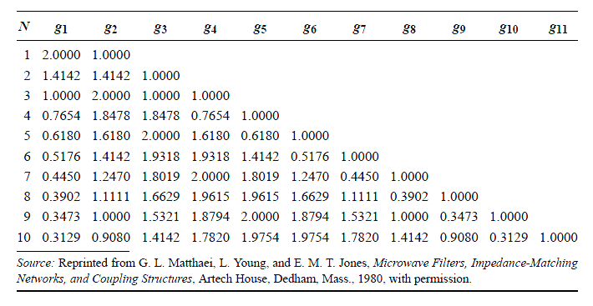

**Table II Element Values for Equal-Ripple Low-Pass Filter Prototypes (*g*0 = 1*,ωc* =1*, N* = 1 to 10, 0.5 dB ripple)**

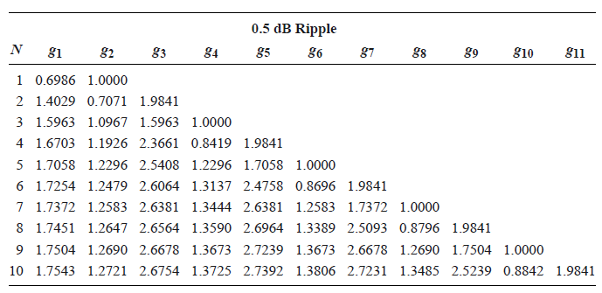

References

1. M. Swaminathan, “Project 2: handout,” unpublished, Mar. 2015.
2. Georgia Tech Virtual Cleanroom Lab, “Photolithography,” unpublished, http://www.ece.gatech.edu/research/labs/vc/theory/photolith.html
3. D. M. Pozar, “Microwave network analysis,” in *Microwave Engineering,* 4th ed. Hoboken, NJ, Wiley, 2012, pp. 198*.*
4. D. M. Pozar, “Microwave filters,” in *Microwave Engineering,* 4th ed. Hoboken, NJ, Wiley, 2012, pp. 380-436*.*
5. M. Swaminathan, “Agilent advanced design systems tutorial,” unpublished, Jan. 2015.